LU

***HOBBIES***

* Reading books
* Designing
* Travelling

***STRENGTHS***

* Strong leadership and motivational skills , works effectively and independently.
* Committed to maintain quality of work , hard working and positive attitude .
* Good communication skills , completes work on time.

***SOFT and HARD SKILLS***

* Communication skills
* Team player attitude
* Growth mindset
* Adaptability
* Time management
* Risk taker
* MS Power point
* MS Excel
* MS Word

***QUALIFICATION***

I0th with 72% ( CBSE )

Greenwood senior secondary school , Rampur

I2th with 82% ( CBSE )

Greenwood senior secondary school , Rampur

BBA ( Persuing )

5th semester

With aggregate 85%

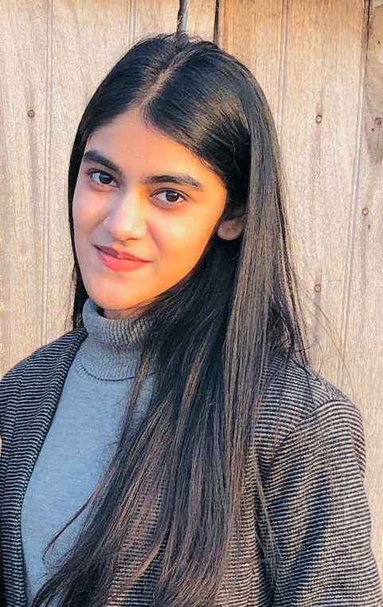

***DECLARATION***

I hereby declare that all the above given information is true to best of my knowledge .

***PERSONAL DETAILS***

Father’s name : Mr . Firoz khan

Mother’s name : Mrs. Darakhshan khan

Date of Birth : 04 August 2003

Nationality : Indian

Languages known : English and Hindi

***ACHIEVEMENTS AND CERTIFICATES***

* Got the certificate in Sports
* Certified in math Olympiad
* Certified in Computer Applications
* Undergone a 20 days summer training of internet applications.

***CAREER OBJECTIVE***

To build a successful career in a growing organization where I can get the opportunities to prove my abilities by accepting challenges , fulfilling organizational goals through continuous learning and commitments .

***CONTACT :***  90583643I7

[Lubnafiroz48@gmail.com](mailto:Lubnafiroz48@gmail.com)

BSNL Jauhar colony Gandhi Samadhi Rampur

*LUBNA FIROZ KHAN*